**BIOLOGY**

**1. A succession that occurs in an area where there are no pre-existing community is called A.** tertiary succession **B.** primary succession **C.** post-primary succession **D.** secondary succession

**2. A community with a population of two million three hundred and ten thousand people living in an area of two thousand three hundred and ten square kilometres has a population density** **of** **A.**10000 **B.**10 **C.** 100 **D.** 1000

**3. Blood group AB is considered as universal recipient because they can receive blood from groups A.** A and O **B.** B and O **C.** AB and O **D.** A, B, AB and O

**4. A trait that is always expressed during crossing of heredity characteristics is A.** recessive trait **B.** dominant trait **C.** homozygous trait **D.** heterozygous

**5. In blood transaction, a patient with group AB receives from A.** Group A, B, AB **B.** Group O, A, B **C.** Group O, B, AB **D.** Group O, A, B, AB

**6. Reproduction in paramecium is by** **A.** binary fission **B.** budding **C.** spore formation **D.** fragmentation

7.

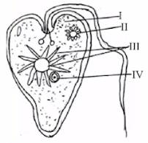

**Use the diagram above to answer the question that follows. The organelle that shows the organism has plant characteristics is** **A.** I **B.** II **C.** III **D.** IV

8.

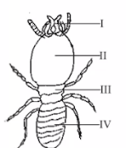

**Use the diagram above to answer the question that follows. The part labelled III is** **A.** abdomen **B.** head **C.** maxillae **D.** thorax

**9. A form of adaptive coloration that helps animals to remain unnoticed is** **A.** hibernation **B.** aestivation **C.** countershading **D.** migration

**10. An example of organism that exhibits counter shading to escape from its predator is** **A.** grasshopper **B.** toad **C.** fish **D.** chameleon

**11. Which of the following processes takes place in the carbon cycle?** **A.** evaporation **B.** nitrification **C.** combustion **D.** transpiration

**12. Body temperature, thirst and hunger are regulated by** **A.** thalamus **B.** hypothalamus **C.** medulla Oblongata **D.** spinal cord

**13. Gaseous exchange takes place through the plasma membrane in** **A.** hydra **B.** paramecium **C.** flatworm **D.** earthworm

**14. In glycolysis, glucose is broken down through series of reactions in the presence of enzyme and absence of oxygen to produce A.** Acetyl-coenzyme + ATP **B.** Phosphorylated glucose **C.** Pyruvic acid + ATP **D.** Amino acid

**15. A photosynthetic carnivorous plant which feeds on insects is** **A.** parasitic **B.** saprophytic **C.** herbivorous **D.** insectivorous

**16. The feeding relationship between ruminants and the bacterial in their digestive tract is A.** saprophytic **B.** parasitic **C.** symbiotic **D.** heterotrophic

**17. The oxygen transported to all parts of the body during blood circulation is used for the A.** growth and development of cells **B.** removal of waste products **C.** release of energy from food **D.** formation of carboxyl haemoglobin

**18. The abiotic factor that affect population growth of an organism is A.** predator **B.** rain fall **C.** food shortage **D.** disease

**19. Which of the following statements explains the theory of natural selection** **A.** There is no struggle for existence **B.** New species get better adaptation **C.** The weaker offspring are eliminated **D.** Unused structures disappear later

**20. The cells responsible for transmitting messages to the effectors are** **A.** motor neurons **B.** sensory neurons **C.** hair cells **D.** relay neurons

**21. One of the characteristics of secondary succession is that it** **A.** starts on a bare surface **B.** takes longer time to reach climax **C.** starts on already colonized surface **D.** starts with low organisms

**22. One of the components of xylem tissue is** **A.** companion cell **B.** tracheid **C.** sieve tube **D.** epidermal

**23.**

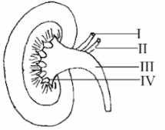

**Use the diagram above to answer the question that follows. The organ is responsible for A.** production of heat **B.** osmoregulation **C.** vasoconstriction **D.** production of hormones

**24. After fertilization in plants, the zygote develops in to** **A.** fruit **B.** an embryo **C.** seed **D.** an endosperm

**25. The chemical and physical composition of soil is an example of** **A.** Climatic factor **B.** Topographic **C.** Edaphic factor **D.** Chemical factor

**26. The rhizoid of liverwort is** **A.** unicellular and unbranched **B.** multicellular and branched **C.** unicellular and branched **D.** multicellular and unbranched

**27. The depressed side of paramecium which is lined with cilia leads to a tube-like structure called** **A.** anal pore **B.** oral groove **C.** gullet **D.** food vacuole

**28. One of the following is a courtship behavior in animals? A.** fighting **B.** display **C.** hibernation **D.** feeding

**29. Production of healthier offspring, viable seeds and formation of new varieties are good characteristics of A.** self-pollination **B.** cross pollination **C.** wind pollination **D.** insect pollination

**30. The pigment carrying oxygen in the blood is** **A.** plasma **B.** haemoglobin **C.** oxyhaemoglobin **D.** erythrocytes

**31. Energy transfer in plants and animals is in the form of** **A.** DNA **B.** ATP **C.** GTP **D.** RNA

**32. Pentadactyl forelimb of vertebrate function due to differences in environment is** **A.** comparative anatomy **B.** physiological evidence **C.** embryological evidence **D.** fossil records

**33. Which of the following evidences of evolution employs the use of radio-isotope dating** **A.** Comparative anatomy **B.** Embryology **C.** Fossil records **D.** Vestigial organs

34.

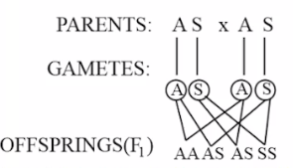

**Use the diagram above to answer the question that follows. What is the genotypic ratio of the offspring produced in the F1 generation?** **A.** 2:1:1 **B.** 1:2:1 **C.** 2:2 **D.** 3:1

**35. How many chromosomes will be present in a gamete if the somatic cell has 8 chromosomes?** **A.** 16 **B.** 6 **C.** 4 **D.** 8

**36. Lamarck’s theory of evolution is based on the idea of** **A.** the inheritance of acquired traits **B.** organisms constantly struggling for existence **C.** organisms’ survival of the fittest **D.** plenty offspring produced by organisms

**37. The central nervous system comprises of** **A.** brain and somatic **B.** brain and spinal cord **C.** spinal cord and somatic **D.** brain only

**38. Which of the following processes releases oxygen to the atmosphere?** **A.** Respiration **B.** Combustion **C.** Decomposition **D.** Photosynthesis

**39. In which zone of the marine habitat does the organisms require adaptation for attachment?** **A.** supratidal **B.** subtidal **C.** intertidal **D.** abyssal zone

**40. Xerophytes are mostly found in the** **A.** arid land **B.** tropical rainforest **C.** montane forest **D.** Sudan savanna

**BIOLOGY 2**

**1. The rhizoid of liverwort is A.** unicellular and unbranched **B.** multicellular and branched **C.** unicellular and branched **D.** multicellular and unbranched

**2. Bryophytes are more advanced than algae because A.** they have stem-like structures **B.** they live in water bodies **C.** they have chloroplast **D.** some are filamentous

**3. The change in colour for adaptation is a special feature in A.** lizards **B.** birds **C.** chameleon **D.** fish

**4.** **The latex that is secreted by Allamanda is an adaptation for** **A.** physical defense **B.** mimicry **C.** chemical defense **D.** escape

**5.** **One of the following is a social insect** **A.** beetle **B.** bee **C.** wasp **D.** cricket

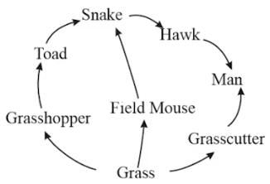

**6. Use the diagram above to answer the question that follows. The organism that occupies the first trophic level is A.** grasshopper **B.** grass cutter **C.** grass **D.** field mouse

**7**. **A natural biome with many plants and animals which can form several food chain is** **A.** grassland **B.** marsh **C.** forest **D.** estuarine

**8**. **Cat fish is adapted to live in habitat with A.** low oxygen **B.** low pressure **C.** high salinity **D.** high acidity

**9**.  **In which of the following Nigerian states can guinea savanna be found? A.** Rivers **B.** Kwara **C.** Ondo **D.** Delta

**10**. **The solid crust of the earth in which plants and animals lived** is **A.** atmosphere **B.** biosphere **C.** lithosphere **D.** hydrosphere

**11**. **The equipment used for measuring turbidity is the A.** Secchi disc **B.** thermometer **C.** rain gauge **D.** hygrometer

**12**. **One of the advantages of inbreeding is that it A.** produces bigger and healthier individual **B.** produces hybrid vigour **C.** produces more resistant organisms to decrease **D.** maintains certain desirable traits

**13**. **How many chromosomes will be present in a gamete if the somatic cell has 8 chromosomes?** **A.** 16 **B.** 6 **C.** 4 **D.** 8

**14**. **In living organisms, the inherited characters are determined by** **A.** environment **B.** gene **C.** mutation **D.** chromosomes

**15. The uptake of mineral salts in plants is by A.** Pitch **B.** Xylem **C.** cambium **D.** phloem

**16.** **The function of the pulmonary vein in the heart is to carry A.** oxygenated blood into the heart **B.** oxygenated blood out of the heart **C.** deoxygenated blood into the heart **D.** deoxygenated blood out of the heart

**17.** **When a colourblind woman marries a normal man without a colourblind trait. What is the probability of their son being colourblind?** **A.**0% **B.**50% **C.** 25% **D.** 100%

**18.** **At what phase of mitotic division does the spindle fibers appear? A.** metaphase **B.** prophase **C.** anaphase **D.** telophase

**19.** **The probability of producing a pink-flowered plant from heterozygous, pink-flowered parent plants is A.** ½ **B.** 2/3 **C.** ¼ **D.** ¾

**20.** **Estuarine organisms are found in between A.** sea and lagoon **B.** Lake and pond **C.** fresh and salty water **D.** River and ocean

**21.** **Tropical rainforest can be found in A.** Kogi **B.** Sokoto **C.** Kwara **D.** Ondo

**22**. **The cells responsible for transmitting messages to the effectors are A.** motor neurons **B.** sensory neurons **C.** hair cells **D.** relay neurons

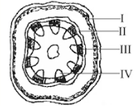

**23**. **Use the diagrams above to answer the question that follows. The part labelled II is the A.** phloem **B.** endodermis **C.** xylem **D.** pericycle

**24**. **In an activity exercising animal muscle, the end product of anaerobic respiration Is** **A.** ethanol and carbon dioxide **B.** lactic acid and energy **C.** pyruvic acid and oxygen **D.** carbon dioxide and oxygen

**25**. **Epigeal types of generation takes place in** **A.** maize **B.** guinea corn **C.** cowpea **D.** millet

**26**. **The idea that many superficially similar looking species arise from different ancestral types is referred to as A.** divergent evolution **B.** adaptive radiation **C.** co-evolution **D.** convergent evolution

**27**. **Sieve tubes in plants are part of the** **A.** xylem **B.** phloem **C.** parenchyma **D.** Sclerenchyma

**28**. **The type of competition between birds of the same species is A.** exploitative **B.** intraspecific **C.** apparent **D.** interspecific

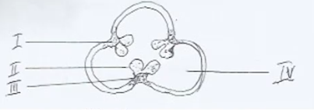

**29**. **Use the diagram above to answer the question that follows. The part labelled II is the A.** placenta **B.** ovule **C.** funicle **D.** chamber

**30**. **An example of agency for conservation of natural resources is** **A.** UNICEF **B.** NCF **C.** WHO **D.** UNESCO

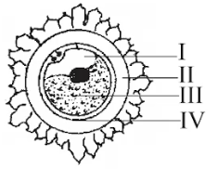

**31**. **Use the diagram above to answer the question that follows. The structure is produced through a process called** **A.** Spermatogenesis **B.** ovulation **C.** copulation **D.** oogenesis

**32**. **The formation of cilia and flagella in living cells is carried out with the help of** **A.** ribosome **B.** lysosome **C.** centriole **D.** plastid

**33**. **One of the conditions that aids cross pollination is A.** dichogamy **B.** homogamy **C.** cleistogamy **D.** self-incompatibility

**34**. **The function of nucleus in cells is to A.** manufacture food **B.** control cellular activities **C.** secrete enzymes **D.** support the cell

**35**. **The appendix in humans which functions as caecum in herbivores is an evidence of evolution from** **A.** embryology **B.** comparative anatomy **C.** fossils records **D.** vestigial organs

**36**. **The wings of a bat and the flipper of a whale are similar in structure and are described as** **A.** homological organs **B.** morphological organs **C.** physiological organs **D.** vestigial organs

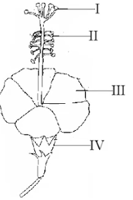

**37**. **Use the diagram above to answer the question that follows. The part whose main function is to attract pollinators is labelled** **A.** I **B.** II **C.** III **D.** IV

**38**. **The function of contractile vacuole in Amoeba is to A.** store food substances **B.** excrete liquid waste **C.** excrete solid waste **D.** secrete hormones

**39**. **Iron is an essential nutrient in plants because it** **A.** aids in the formation of chlorophyll and proteins **B.** helps in cell division **C.** protects the plant from pest attack **D.** fastens fruit maturation

**40**. **Photosynthetic plants which feed on insects and other pitcher plants are** **A.** Saprophytes **B.** parasites **C.** herbivorous **D.** carnivorous

**BIOLOGY 3**

**1. The food nutrient with the highest energy value is** **A.** protein **B.** carbohydrate **C.** lipid **D.** minerals

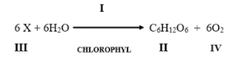

**2. Use the diagram above to answer question that follows. The part labelled I is A.** enzyme **B.** water **C.** sunlight **D.** chemical

**3. The transmission of diseases through contamination of food is an economic importance of A.** mosquitoes **B.** cockroaches **C.** butterflies **D.** bees

**4.** **Bryophyte is an intermediate group between higher algae and A.** Thallophyte **B.** pteridophyte **C.** spermatophyte **D.** tracheophyte

**5.** **The major building block of an organism is A.** nitrogen **B.** carbon **C.** water **D.** Sulphur

**6**. **The process by which plants loss water to the atmosphere is** **A.** transpiration **B.** guttation **C.** translocation **D.** evaporation

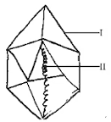

**7**. **Use the diagram above to answer the question that follows. The organism belong to kingdom A.** monera **B.** Protista **C.** fungi **D.** Animalia

**8**. **The formation of cilia and flagella in living cells is carried out with the help of A.** ribosome **B.** lysosome **C.** centriole **D.** plastid

**9**. **The changes of living organisms over generation is referred to as A.** human evolution **B.** organic evolution **C.** physical evolution **D.** chemical evolution

**10**. **In a cross involving a heterozygous red flower plant (Rr) and a white flowered plant (rr), what is the probability that the offspring will be Rr? A.** ½ **B.** 1 **C.** 2 **D.** ¼

**11**. **Inbreeding is highly discouraged in humans because it may A.** increase the death rate of new born **B.** lead to the birth of dwarfs’ **C.** lead to high rate of competition among offspring **D.** lead to outbreak of hereditary diseases

**12. Which of the Nigeria states is guinea savanna located**? **A.** Borno **B.** Kano **C.** Oyo **D.** Kwara

**13. Which of the following plant is found in the ground layer of a tropical rain forest in Nigeria? A.** Obeche **B.** Liverwort **C.** Mahogany **D.** Oil Palm

**14.** **In vascular plants, xylem tissue is responsible for A.** transportation of water **B.** translocation of food **C.** transportation of hormones **D.** storage of sugar

**15. Which of the following plants shows hypogeal germination? A.** Castor oil **B.** Groundnut **C.** Maize **D.** Orange

**16.** **The type of skeleton possess by earthworm is A.** exoskeleton **B.** endoskeleton **C.** hydrostatic skeleton **D.** skeletal muscle

**17. Which of the following population sampling techniques will be most suitable for use in estimating the population size of rats? A.** Direct count method **B.** Quadrat sampling method **C.** Capture, release, recapture method **D.** Census method

**18. The causative agent of tuberculosis is A.** virus **B.** bacteria **C.** protozoa **D.** fungi

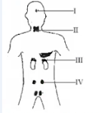

**19. Use the diagram above to answer the question that follows. The endocrine gland that is located in the part labelled I is A.** thyroid **B.** adrenal **C.** parathyroid **D.** pituitary

**20. Comparative anatomy to study evidence for evolution depends on A.** four fingered **B.** three fingered **C.** two fingered **D.** five fingered

**21. Which of these is a respiratory organ in mammals? A.** Skin **B.** Mouth **C.** Heart **D.** Lungs

**22. Which of the following technique is not used for vegetative propagation?** **A.** Cutting **B.** Grafting **C.** Budding **D.** Layering

**23.** **Which of these pair of substances must be present for a seed to germinate in a laboratory setup? A.** Microbes and water **B.** Heat and water **C.** Soil and manure **D.** Heat and microbe

**24.** **A fruit formed from one flower with many carpels is referred to as A.** simple **B.** multiple **C.** aggregate **D.** false

**25.** **Bilateral symmetry, cylindrical bodies and double openings, are characteristic features of A.** nematodes **B.** hydra **C.** protozoa **D.** protists

**26**. **Mouth part adapted for piercing and sucking is found in A.** housefly **B.** grasshopper **C.** mosquito **D.** cockroach

**27**. **The web-feet of frogs and toads is basically for A.** leaping **B.** walking **C.** swimming **D.** mating

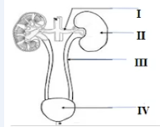

**28**. **Use the diagram above to answer the question that follows. The diagram above is** **A.** circulatory system **B.** reproductive system **C.** urinary system **D.** nervous system

**29**. **Bile is a greenish alkaline liquid which is stored in the A.** gall bladder **B.** liver **C.** stomach **D.** pancreas

**30. The part of the inner ear that in responsible for hearing is A.** sacculus **B.** cochlea **C.** utriculus **D.** ampullae

**31. The ecological instrument use to measure the cloudiness and transparency of water is A.** Secchi disc **B.** Hygrometer **C.** Thermometer **D.** Rain gauge

**32**. **Ecological succession can result from A.** newly formed habitat **B.** habitat with abundant food **C.** habitat with space and light **D.** population of plants on a fertile land

**33**. **The first organism evolved from which of the following habitat? A.** Terrestrial **B.** Arboreal **C.** Aquatic **D.** Desert

**34. A medium texture soil with high organic matter is A.** clay **B.** loamy **C.** humus **D.** sandy

**35.** **One of the following is an example of discontinuous variation** **A.** shape of the head **B.** blood group **C.** body complexion **D.** pointed nose

**36. The type of variation where there are no remarkable differences between the two extreme individuals is called A.** continuous variation **B.** morphological variation **C.** physiological variation **D.** discontinuous variation

**37. The type of variation where there are no remarkable differences between the two extreme individuals is called A.** continuous variation **B.** morphological variation **C.** physiological variation **D.** discontinuous variation

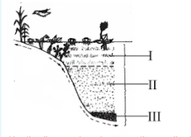

**38. Use the diagram above to answer the question that follows. The zone labelled II is called A.** supra- tidal zone **B.** pelagic zone **C.** littoral zone **D.** benthic zone

**39. Which of the following structures enables the exchange of gases in insects**? **A.** Skin **B.** Tracheae **C.** Malpighian tubules **D.** Flame cell

**40**. **The total number of ATP produced during glycolysis is A.** 3 molecules **B.** 2 molecules **C.** 4 molecules **D.** 6 molecules

**BIOLOGY 4**

**1. The cell organelle responsible for the synthesis of protein is the** **A.** centriole **B.** vacuole **C.** plastid **D.** ribosomes

**2. Which of the following characteristics is possessed by both living and non-living things? A.** Both age and die **B.** Both have life **C.** Both have weight **D.** Both have no shape

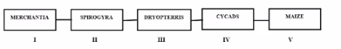

**3. Use the diagram above to answer question that follows. Examples of non-vascular plants are labelled A.** I and II **B.** I and III **C.** II and III **D.** II and IV

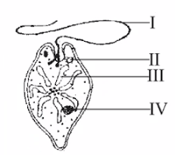

**4.** **Use the diagram above to answer question that follows. The organ responsible for food production is labelled A.** I **B.** II **C.** III **D.** IV

**5**. **The resemblance of an organism to another organism as a means of enhancing its chances of survival in its habitat is called A.** counter shading **B.** protective colouration **C.** mimicry **D.** warning

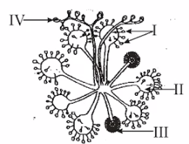

**6**. **Use the diagram above to answer question that follows. The part labelled II is the A.** stem **B.** leaf **C.** fruit **D.** flower

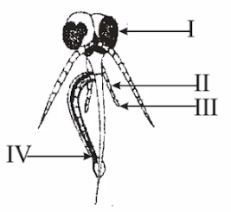

**7**. **Use the diagram above to answer question that follows. The part which contains the salivary gland is called A.** mandible **B.** labrum **C.** hypopharynx **D.** labium

**8. The Sclerenchyma tissue consists of two types of cells namely A.** fibers and sclereid **B.** tracheid and sclereid **C.** fibers and tracheid **D.** tracheid and vessel element

**9.** **A form of feeding in which two organisms live in close association with each other for the benefit of both is A.** Saprophytic **B.** Parasitic **C.** Symbiotic **D.** Holozoic

**10**. **In the light reaction stage of photosynthesis, the light energy is captured by A.** hydrogen ions **B.** chlorophyll **C.** light rays **D.** carbon(iv)oxide

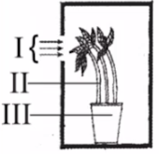

**11**. **Use the diagram above to answer question that follows. The diagram demonstrates A.** thigmotropism **B.** phototropism **C.** geotropism **D.** hydrotropism

**12**. **The component that serves as major buffer in blood is A.** plasma **B.** erythrocytes **C.** leucocytes **D.** lymph

**13**. **The basic component of cell sap is A.** water **B.** hydrogen **C.** nitrogen **D.** oxygen

**14**. **The excretory organ of the earthworms is the A.** flame cell **B.** Malpighian tubule **C.** nephridium **D.** contractile vacuole

**15. The urinary tubule opens into a proximal convoluted tubule coils to form distal by making a A.** Z-shaped loop **B.** L-shaped loop **C.** U-shaped loop **D.** I-shaped loop

**16**. **Production of healthier offspring, viable seeds and formation of new varieties are characteristics of A.** self-pollination **B.** cross pollination **C.** wind pollination **D.** insect pollination

**17**. **In Euglena, excess water and metabolic waste products are excreted through the A.** flagellum **B.** chloroplast **C.** nucleus **D.** contractile vacuoles

**18**. **The process in which living things give rise to members of its own kind is A.** excretion **B.** reproduction **C.** nutrition **D.** respiration

**19**. **The process of absorption of food substances in mammalian embryo is via A.** osmosis **B.** diffusion **C.** plasmolysis **D.** haemolysis

**20**. **The part of the brain that receives sensory impulses of smell is the A.** olfactory lobe **B.** medulla oblongata **C.** cerebrum **D.** cerebellum

**21**. **Lack of space in population could lead to an increase in A.** drought **B.** water scarcity **C.** death rate **D.** disease rate

**22**. **Infectious diseases are caused by** **A.** bacteria **B.** fungi **C.** amoeba **D.** protozoa

**23**. **The factor that increases population growth is A.** food availability **B.** natural disaster **C.** high mortality **D.** competition

**24**. **High temperature and very low rainfall is a characteristic of A.** sahel savanna **B.** sudan savanna **C.** southern guinea savanna **D.** northern guinea savanna

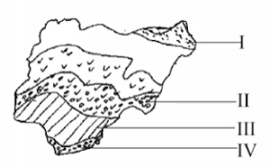

**25**. **The part labelled II is the** **A.** tropical rain forest **B.** mangrove swamps **C.** sudan savanna **D.** guinea savanna

**26. A plant that grows on another plant is A.** mesophyte **B.** xerophyte **C.** epiphyte **D.** hydrophyte

**27.** **One of the characteristics of the loamy soil is that it is A.** easily heated by sun **B.** easy to cultivate **C.** easily waterlogged **D.** poorly aerated

**28. Which of the following factors can lead to overcrowding? A.** Emigration **B.** Competition **C.** High natality **D.** Low mortality

**29**. **The common examples of trees found in the desert are A.** raffia palm and coconut **B.** baobab and cacti **C.** white and red mangrove **D.** shea-butter and isobelina

**30**. **One of the ways of controlling Schistosomiasis is by A.** destroying water snails and water weeds **B.** clearing the bushes around the house **C.** washing hands after using the toilet **D.** properly washing fruits before eating them

**31**. **One of the characteristic of secondary succession is that it A.** starts on a bare surface **B.** takes longer time to reach climax **C.** starts on already colonized surface **D.** starts with low organisms

**32**. **Which of these types of variations could change as a result of change in the environment? A.** Fingerprint **B.** Ability to roll tongue **C.** Height of the body **D.** Blood group

**33**. **A discontinuous morphological variation often used in crime detection is the A.** skin colour **B.** blood group **C.** finger prints **D.** eye colour

**34**. **DNA carries the genetic information and are generally found in the A.** ribosomes **B.** chromosomes **C.** blood **D.** enzymes

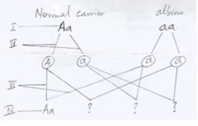

**35**. **Use the diagram above to answer the question that follows. Recombination of genes at fertilization is represented by the part labelled A.** Ι **B.** ll **C.** III **D.** IV

**36**. **Hemophilia in humans Is controlled by the A.** blood group **B.** dominant gene **C.** rhesus factor **D.** recessive gene

**37**. **If the F1 generation allows for self-pollination, what will be the genotypic ratio of the offspring? A.** 1:2:1 **B.** 2:2 **C.** 3:1 **D.** 2:1:1

**38**. **Darwin's theory of evolution is based on the principle of A.** use and disuse of organs **B.** natural selection **C.** acquired characteristics **D.** mutation

**39**. **Similar structures that are modified to work in different ways in different organisms are referred to as** **A.** homologous structures **B.** analogous structures **C.** divergent structures **D.** convergent structures

**40. The evolutional evidence of living organisms and their extinct relative is A.** comparative anatomy **B.** paleontology **C.** embryology **D.** vestigial organs

**BIOLOGY 5**

**1. Which of the following tissues is responsible for secondary thickening in plants? A.** Phloem B. Xylem C. Cambium D. Collenchyma

**2.** **Cell division that involves the growth, development, repair and replacement of worn out tissue is A.** biosynthesis B. mitosis C. meiosis D. synthesis

**3.** **An example of discontinuous variation includes A**. ability to taste PTC B. skin colour C. weight D. height

**4**. **The use of mouth for respiration in toad is** **called A.** cutaneous respiration B. buccal respiration C. pulmonary respiration D. aerobic respiration

**5**. **The number of cervical vertebrate found in the of a** **rabbit is** A. 7 B. 5 C. 4 D. 12

**6**. **The soil type with coarse particles and lowest water holding capacity is A.** sand B. silt C. clay D. loam

**7**. **Which of the following plants exhibits epigeal germination? A**. Guinea corn B. Millet C. maize D. Mango

**8**. **The chemical and physical composition of soil is an example of A.** Climatic factor B. Topographic factor C. Edaphic factor D. Chemical factor

**9**. **A natural force that can cause evolutionary change in living organisms is A**. mutation B. gene type C. gene flow D. gene pool

**10**. **Possession of special features which improve the chances of an organism to survive in its environment is A.** competition B. succession C. adaptation D. evolution

**11**. **The universal recipient is the person with blood group A**. AB B. A C. O D. B

**12**. **The brightly coloured adult male lizard displaying itself is for the purpose of A.** basking B. mating C. defence D. feeding

**13.** **Human race with the characteristic of light skin, narrow nose and wavy hair is A.** causasoid B. negroid C. mongoloid D. australoid

**14.** **An example of physiological variation is the A**. ability to taste PTC B. skin colour C. finger prints D. height of body

**15. A non-heritable character is** **the** A. Rhesus factor B. ABO blood group C. well-developed muscle D. sex of a child

**16. The major factor affecting the distribution of photosynthetic organisms in water during raining season is A.** pressure B. turbidity C. humidity D. PH

**17. The most important abiotic factor that affects the biotic community of a terrestrial habitat is A.** light intensity **B.** wind **C.** temperature **D.** rainfall

**18. In glycolysis, glucose is broken down through series of reactions in the presence of enzyme and absence of oxygen to produce A.** Acetyl - coenzyme + ATP B. Phosphorylated glucose C. Pyruvic acid + ATP **D.** Amino acid

**19. The excretory structure in earthworm is A.** cuticle **B.** nephridia **C.** trachea **D.** skin

**20. A complex feeding relationship between organisms in a habitat that involves transfer of energy in form of food is A.** food chain **B.** pyramid of energy **C.** food web **D.** pyramid of numbers

**21. Benue state is found in which of the following Nigeria savanna? A.** Sahel **B.** Derived **C.** Sudan **D.** Guinea

**22. The variation used to detection a child's paternity is A.** fingerprint **B.** tongue rolling **C.** blood group **D.** behavior

**23. If a rhesus negative person receives Rh positive blood it results to A.** neutralization **B.** agglutination **C.** leukaemia **D.** clotting

**24. Fingerprints are commonly used in crime detection because A.** they are more visible and easy to differentiate **B.** Government already has the database of all fingerprints **C.** it is easily gotten from surfaces of objects of crime **D.** no two persons have the same fingerprints

**25. The insects mostly involved in the distribution of wood are the A.** cockroaches B. mites C. termites D. beetles

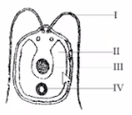

**26.** **Use the diagram above to answer the question that follows. The part that controls all cellular activities is labelled** A. II B. IV C. III D. Ι

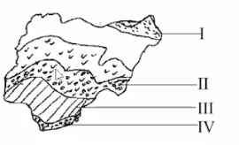

**27. Use the diagram above to answer the question that follows. The part labelled I is characterized by A.** heavy rainfall and broad-leaved trees **B.** light rainfall, tall and scattered trees **C.** hot rainy season and tropical grassland **D.** low rainfall and very sparse vegetation

**28. Water lettuce and water lily plants are adapted to withstand small wave action located at A.** surface zone **B.** surface edge zone **C.** middle zone **D.** bottom zone

**29. In animals, the mineral salts from the alimentary canal is transported to the A.** lungs **B.** heart and liver **C.** kidney **D.** bones and teeth

**30. The formation of a brick-red precipitate is usually a result obtained in which of these tests? A.** Iodine test B. Biuret's test C. Osmic acid test D. Million's test

**31. Which of these is characteristic of a typical plant cell?** A. Centriole is present B. Centriole is absent C. Cytoplasm is large D. Food is stored as glycogen

**32.** **The vegetative part of the flowering plant is A**. Roots B. Stems C. Leaves D. Flowers

**33**. **The zone of the marine habitat exposed to dry conditions at low tides and covered by water at high tides is the A.** splash zone B. inter-tidal zone C. littoral zone D. benthic zone

**34**. **The type of habitat in which the water salinity fluctuates as a result of the mixture of fresh and sea water is A.** fresh water B. marsh C. marine D. estuarine

**35. Which of the following is the first vertebrates to evolve? A.** Frog B. Fish C. Bird D. Lizard

**36.** **Ecological succession can result from A.** newly formed habitat B. habitat with abundant food C. habitat with space and light D. population of plants on a fertile land

**37.** **A major characteristic of the atlas is that A**. neural spine is short or absent B. it has a narrow neural canal C. ransverse section is reduced D. it has a large centrum

**38**. **A major characteristic of the atlas is that A**. neural spine is short or absent B. it has a narrow neural canal C. transverse section is reduced D. it has a large centrum

**39**. **In human alimentary canal, pepsin convert protein to** A. amino acid B. polypeptides C. peptone D. chyme

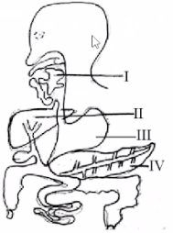

**40. Use the diagram above the answer the question that follows. An enzyme secreted in part labelled I acts on which class of food? A.** Protein **B.** Carbohydrate **C.** Lipids **D.** Vitamin

**BIOLOGY 6**

**1. The organelle that is absent in a plant cell is** A. chloroplast B. centriole C. ribosome D. mitochondria



**2. Use the diagram to answer the question that follows. The flower of plants belongs to the part labelled A**. I B. II C. III D. IV

**3**. **The depressed side of paramecium which is lined with cilia leads to a tube-like structure called A.** anal pore B. oral groove **C.** gullet **D.** food vacuole

**4**. **Which of the following shows alternation of generation? A.** Liverworts **B.** Fern **C.** Spirogyra **D.** Moss

**5**. **Bilateral symmetry, cylindrical bodies and double openings, are characteristic features of A**. nematodes B. hydra C. protozoa D. protists

**6**. **Which of the following conditions causes aestivation in animals?** **A.** Wind **B**. Drought **C.** Rain **D.** Cold

**7**. **The cone in the retina of the eye is an example of A**. cell **B.** tissue **C.** organ **D.** system

**8**. **The sclerenchyma tissues consist of A.** dead cell **B.** living cell **C.** tracheid cell **D.** meristematic cell

**9**. **The bacteria in the large intestine of man synthesizes A.** vitamins and mineral **B.** vitamins and glucose **C.** amino acids and vitamins **D.** amino acids and minerals

**10**. **The mineral required for the formation of red blood cells in animals is A.** calcium **B.** sodium **C**. iron **D.** iodine

**11**. **A common component of blood and lymph is A.** fats **B.** plasma **C.** red blood cell **D.** white blood cell

**12**. **Which of these is a medium of transportation in plants? A.** Cell sap B. Nucleus C. Mitochondria D. Ribosome

**13**. **A characteristic feature common to gills and lungs as respiratory organ is that they A**. have surface not kept moist B. are highly vascularized C. are internally situated D. are always exposed to the atmosphere

**14**. **The part of the kidney where selective reabsorption takes place is A.** glomerulus B. Bowman’s capsule C. Henle’s loop D. urethra

**15**. **The main excretory product of earthworm A.** ammonia B. carbon dioxide C. urea D. uric acid

**16**. **The number of vertebrae in the human vertebral column is** A. 30 B. 33 C. 38 D. 39

**17**. **The closing of the leaflets of the flamboyant tree due to low light intensity is an example of A.** tropic movement B. nastic movement C. tactic movement D. photoperiodic

**18**. **The part of a flower that develops into seed is A.** ovule B. pedicel C. petal D. style

**19**. **An example of propagation where plant receive light and nutrient from its parent is A.** grafting B. budding C. layering D. cutting

**20**. **The type of circulation whereby blood is taken from the heart to the lungs of man is A**. system circulation B. open circulation C. pulmonary circulation C. double circulation

**21**. **The Sudan savanna can be found in A.** Kano state B. Kwara state C. Bauchi state D. Niger state

**22**. **The response of a part of fixed plant to a non-directional or diffuse stimulus is referred to as A.** tactic B. nastic C. tropic D. diffuse

**23**. **An instrument used for measuring the intensity of light A.** thermometer B. photometer C. anemometer D. hygrometer

**24**. Th**e organisms that adopt swarming as an adaptation to overcome overcrowding are A.** Agama lizards B. tilapia C. rats D. termites

**25**. **The conversion of nitrates to nitrogen gas by certain bacteria is A.** ammonification B. putrifaction C. denitrification D. nitrification

**26**. **The structural adaptation of savanna plants to conserve water is A.** large and leathery leaves B. long and needle-like leaves C. small and airy leaves D. small and thick leaves

**27**. **The possession of pneumatophores is one of the adaptations of plants found in A**. tropical rain forest B. evergreen forest C. deciduous forest D. mangrove forest

**28**. **Loamy soil is characterized by A.** low humus and high porosity B. high humus and high porosity C. moderate humus and low porosity D. high humus and moderate porosity

**29**. **Which of these methods is used to determine the population density of animals in a habitat? A**. Group method B. Quadrat method C. Capture method D. Transect method

**30**. **Shallow lake gradually filled up with vegetation to become a marsh and a forest is an example of A.** secondary succession B. primary succession C. climax community D. ecosystem

**31**. **Which of the following is a viral disease? A.** Syphilis B. Measles C. Cholera D. Typhoid

**32**. **The soil that contains high humus content is A.** sandy B. clay C. silt D. loamy

**33**. **An example of morphological variations include A.** height B. tongue rolling C. ability to taste PTC D. blood group

**34. Antibodies are found in the A.** red blood cell B. white blood cell C. blood plasma D. blood platelet

**35.** **A heterozygous tongue roller (Tt) marries a non-tongue roller (tt). The phenotypic ratio of their offsprings is A**. 3:1 B. 1:1 C. 1:2:1 D. 1:1:1:1

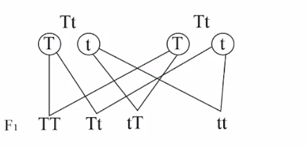

**36**. Use the illustration above to answer the question that follows A. ¼ B. ½ C. ¾ D. 2/5

**37**. **The pea plant was most suitable for Mendel's study because it is A**. wind pollinated B. water pollinated C. insect pollinated D. self-pollinated

**38**. **According to Darwin's theory, the driving force behind evolutionary change is A.** genetic drift B. mutation C. gene flow D. natural selection

**39**. V**ertebrates are believed to have evolved from common ancestors and develop a phylogenetic relationship by having a A.** homologous structure B. skeletal system C. endocrine system D. body covered with hair

**40**. **The postulate which explains that the species of organisms have the ability to produce large number of offsprings into the environment was by A.** Lamarck B. Darwin C. Mendel D. Robert Hooke

**BIOLOGY 7**

**1. The function of endoplasmic reticulum is for the A.** production of energy B. lipid synthesis C. packing of steroids D. transport of materials

**2. In which level of organization of life does hydra belong to? A.** Cell B. Tissue C. Organ D. System

**3.** **Bacteria are usually referred to as prokaryotic cells because they A.** are aquatic B. are shapeless C. do not have organized nucleus D. cannot be seen without a microscope

**4.** **Which of the following organelles is responsible for locomotion in paramecium A.** Contractile vacuole B. Oral groove C. Cilia D. Pellicle

**5.** **Double circulation takes place in A.** fish B. lizard C. toad D. rabbit

**6.** **Use the diagram below to answer the question that follows. Which of the parts labelled is used for piercing through the skin? A.** I B. II C. III D. IV

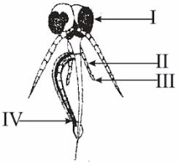

**7. Counter shading is found in A.** chameleons B. crabs C. crayfish D. tilapia

**8.** **The differences between a monocotyledonous root and a dicotyledonous root is the A.** presence of pitch B. presence of cambium C. scattered vascular bundles D. star-shaped xylem

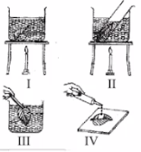

**9.** **Use the diagram above to answer the question that follows. The experiment is setup to determine the presence of A.** chlorophyll B. starch C. oxygen D. pigment

**10.** **Iron is an essential nutrient in plants because** it A. aids in the formation of chlorophyll and proteins B. helps in cell division C. protects the plant from pest attack D. fastens fruit maturation

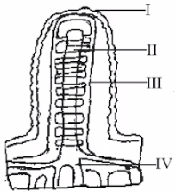

**11.** **Use the diagram above to answer the questions that follow. The tissue above is located in the** A. gullet B. stomach C. large intestine D. small intestine

**12. The type circulatory system found in arthropods and some mollusk is A.** opened circulatory system B. close circulatory system C. single circulatory system D. double circulatory system

**13.** **Diffusion is sufficient for transport of materials between the surface and cells of A.** flatworm B. earthworm C. snail D. cockroach

**14.** T**he excretory structure in earthworm is A.** cuticle B. nephridia C. trachea D. skin

**15.** **During the process of excretion in insects, nitrogenous waste products and water are firstly released in to the A**. rectum B. haemocoel C. proximal tubule D. distal tubule

**16.** **In plants the main excretory product produced during metabolism is** A. oxygen B. alkaloids C. carbon(iv) oxide D. mucilage

**17. Which of the following organisms reproduce by binary fission? A.** Amoeba B. Spirogyra C. Euglena D. Fungi

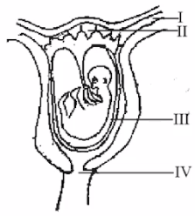

**18.** **Use the diagram above to answer the questions that follows. The part labelled I is A**. oviduct B. placenta C. amnion D. uterus

**19**. **The main organ of excretion in insects is the A.** kidney B. nephridia C. nephron D. Malpighian tubules

**20. The endocrine gland that is called the master gland is A.** thyroid gland B. pancreas C. pituitary gland D. adrenal gland

**21. The instrument used for measuring relative humidity of a place is A.** hygrometer B. rain gauge C. anemometer D. wind vane

**22.** **An association between two organisms in which one benefits and the other suffers is A.** predation B. commensalism C. parasitism D. symbiosis

**23. An association between flowering plants and bees is an example of A.** parasitism B. symbiosis C. commensalism D. saprophytism

**24.** **In marine habitat, the littoral zone is subdivided into A.** splash, intertidal and subtidal zones B. intertidal and subtidal zones C. benthic, intertidal and subtidal zones D. benthic and splash zone

**25.** **Which of the following association is an example of mutualism? A.** Oyster and crab B. Man and tapeworm C. Mistietoe and flowering plant D. Protozoa in the intestine of termites

**26.** **Example of an organism found in mangrove swamp forest is A.** oyster B. zebra C. squirrel D. antelope

**27.** **An example of marine organisms is A.** barnacle B. protopterus C. hydra D. duck

**28.** **The association between man and plasmodium is termed A.** amensalism B. commensalism C. parasitism D. mutualism

**29.** **Which of the following is a deleterious effect of overcrowding? A**. Decreased reproduction B. Rapid dispersion C. Increased predation D. Disease outbreak

**30.** **One of the ways of controlling schistosomiasis is by** A. destroying water snails and water weeds B. clearing the bushes around the house C. washing hands after using the toilet D. properly washing fruits before eating them

**31. A community that remains the same in its composition and size for a long period of time is A.** Primary succession **B.** climax community C. secondary succession **D.** serial community

**32.** **Which of the following is an example of continuous variation in man**? A. Intelligence B. Ability to roll the tongue C. Blood group D. Ability to taste PTC

**33**. **The clumping of red blood cell is called A.** variation B. agglutination C. mutation D. transfusion

**34**. **Agglutination is likely to occur if blood group O+ is transfused into individuals of blood group** A. A+ B. B+ C. AB- D. Ο-

**35**. **The universal donor among the blood groups is A.** A B. B C. AB D. O

**36**. **A cross between an albino female and a genetically normal male will result in offspring that are** A. all genetically normal B. all phenotypically normal C. half genetically normal D. half phenotypically normal

**37**. **What is the genetic ratio of a cross between a heterozygous (Tt) maize plant and a homozygous short (tt) maize plant? A.** 2:1 B. 2:2 C. 3:1 D. 1:3

**38**. **An evidence of evolution that shows that DNA of closely related species show more similarities than distant species is A.** comparative anatomy B. molecular records C. micro evolution D. fossil records

**39**. **Random changes in the DNA base composition is referred to as A.** radiation B. mutation C. recombination D. hybridization

**40**. **In evolution, the main force believed by scientists that regularly produces evolutionary change is A**. mutation B. variation C. natural selection D. heredity

**BIOLOGY 8**

1. **The vegetative part of the flowering plant is A**. Roots B. Stems C. Leaves D. Flowers

**2**. **Which of these organelles can be found in both plant and animal cells A**. Cell wall B. Chloroplast C. Mitochondrion D. Large vacuole

**3**. **The process by which plants loss water to the atmosphere is** A. transpiration B. guttation C. translocation D. evaporation

**4**. **Nitrogen fixing bacteria within the root nodules of some plants covert nitrogen gas to A**. ammonia B. carbon C. Sulphur D. nitrate

**5**. **In glycolysis, glucose is broken down through series of reactions in the presence of enzyme and absence of oxygen to produce A.** Acetyl-coenzyme + ATP **B.** Phosphorylated glucose **C.** Pyruvic acid + ATP **D.** Amino acid

**6**. **The excretory product of the mammalian skin is** **A.** carbon (IV) oxide B. uric acid C. sweat D. oxygen

**7**. **The variation used to detection a child's paternity is A.** fingerprint B. tongue rolling C. blood group D. behavior

**8**. **Agglutination occur when blood group A**. A donates to AB B. A receives from AB C. B receives from O D. AB receives from B

**9. Which of the following can be used to detect a rapist? A.** Blood group **B.** Rhesus factor **C.** Finger prints **D.** Blood genotype

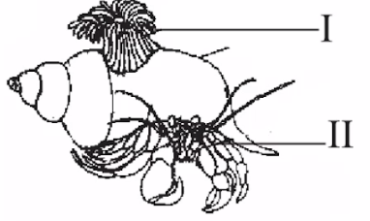

**10. Use the diagram above to answer questions that follow. The association between the two organisms labeled I and II is A.** parasitism **B.** predator-prey **C.** mutualism **D.** ammensalism

**11. The correct sequence of a typical food chain in an aquatic habitat is A.** Diatom → crustacea → fish → king fisher **B.** Plankton → fish → crustacea → diatom **C.** Fish → crustacean →man → diatom **D.** Crustacea → fish → diatom → man

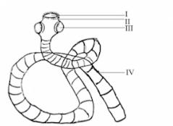

**12. Use the diagram above to answer the question that follows. The organism illustrated is of economic importance to man because it A.** absorbs digestive enzymes **B.** irritates the intestinal walls **C.** Increases the rate of digestion **D.** supplies nutrient to the body

**13.** **An organism that exhibits both plant and animal characteristics is** A. Paramecium B. Euglena C. Amoeba D. Chlamydomonas

**14. The zone of the marine habitat characterized by cold dark water is A.** littoral zone B. euphotic zone C. neritic zone D. aphotic zone

**15. Which of the following characteristics describe the type of vegetation found in Rivers, Delta and Lagos state? I. Presence of tall woody trees II. Annual rainfall of over 250cm throughout the year III. Animals found are antelopes, lions and leopard IV. Grasses are short and scanty V. Water found is a combination of fresh and salt water A.** I II and III **B.** II III and IV **C.** III IV andV D. I II and V

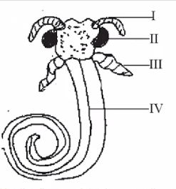

**16.** **Use the diagram above to answer the question that follows. The structure illustrated represents the mouth parts of a A.** mosquito **B.** cockroach **C.** butterfly **D.** weevil

**17.** **The dark dorsal surface and the silvery ventral surface in cat fish is an example of** A. mating colouration B. counter shading C. warning coloration D. mimicry

**18. The body of the class Arachnida is basically divided into A.** 2 B. 1 C. 3 D. 4

**19.** **The cells responsible for transmitting messages to the effectors are** A. motor neurons B. sensory neurons C. hair cells D. relay neurons

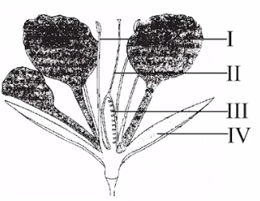

**20. Use the diagram above to answer the question that follows. The pollen grains are produced from the part labelled A.** Ι **B.** ll **C.** III **D.** IV

**21.** **Shallow lake gradually filled up with vegetation to become a marsh and a forest is an example of A.** secondary succession **B.** primary succession **C.** climax community **D.** ecosystem

**22.** **The origin of species by natural selection was postulated by** A. Jean Lamarck B. Hugo De Vries C. Charles Darwin D. Gregor Mendel

**23. The U-shaped structure in the nephron is called A.** proximal convoluted tubule **B.** loop of Henle **C.** distal convoluted tubule **D.** bowman capsule

**24.** **An association that has much harm done to one of the partner is A.** mutualism **B.** symbiosis **C.** commensalism **D.** parasitism

**25.** **The tissue composed of two dead cells and deposits of lignin is the** A. collenchyma B. sclerenchyma C. xylem D. phloem

**26. The structure responsible for the absorption of digested food from the intestine is A.** liver **B.** villus **C.** cilium **D.** lumen

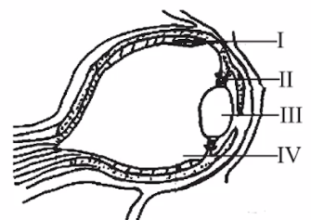

**27. Use the diagram above to answer the questions that follow. The part labelled III is the A.** cornea **B.** retina **C.** lens **D.** iris

**28.** **The order of evolutionary trend in plant is** A. Bryophyta, Thallophyta, Pteridophyta and Spermatophyta B. Thallophyta, Bryophyte, Pteridophyta and Spermatophyta C. Spermatophyte, Pteridophyta, Bryophyte and Thallophyta D. Thallophyta Bryophyte, Spermatophyte and Pteridophyta

**29. The wing of a bat and that of a bird is an example of A.** adaptive radiation **B.** divergent evolution **C.** vestigial structures **D.** continuous variation

**30.** **Which of these types of teeth is lowest in number in the dental formula of a herbivore? A.** Incisor **B.** Canine **C.** Premolar **D.** Molar

**31.** **In animals, the mineral salts from the alimentary canal is transported to the** A. lungs B. heart and liver C. kidney D. bones and teeth

**32. Ecdysis occurs in insects due to the need for them to A**. grow B.respire C. reproduce D. excrete

**33**. **The process of formation of gametes in the female human reproductive system is A.** spermatogenesis B. ovulation C. implantation D. oogenesis

**34**. **The correct option that complies with Mendel's inheritance** A. polygenic inheritance B. multiple alleles C. single factor inheritance D. sex linked character

**35**. **One of the benefits of forest conservation is to prevent** A. foreign exchange B. bush burning C. wildlife extinction C. water conservation

**36**. **The great changes in the environment that resulted in corresponding changes in the species was postulated by A.** Darwin B. Lamarck D. Robert Hook D. Gregor Mendel

**37**. **Which of the following biotic communities in Nigeria has tall trees with thick canopies?** A. Southern guinea savannah B. Tropical rain forest C. Tropical grass land D. Northern guinea savannah

**38**. **In a field experiment, the frequency of waterleaf was observed to be 100 after 25 tosses of a 4m² quadrant. What is the population density of the plant in the field?** A. 1m-2 B. 625m-2 C. 100m-2 D. 2m-2

**39**. **One example of a water soluble vitamin is A.** vitamin B B. vitamin A C. vitamin D D. vitamin K

**40**. **Absorption of proteins during digestion takes place in the A.** mouth B. stomach C. duodenum D. ileum